**Coffee Shop Sales Analysis**

# **Project Description:**

Analysing The Coffee Shop Data Using Microsoft Excel for Data Collection and Microsoft SQL Server for firing SQL Queries to solve the Business Problems.

# **Step by Step Process:**

1. Data Walkthrough
2. Raw Data File Preparation
3. Creating Database
4. Importing File
5. Cleaning Importing File
6. Firing SQL Queries for Business Requirements
7. Storing Results

**Data Walkthrough**

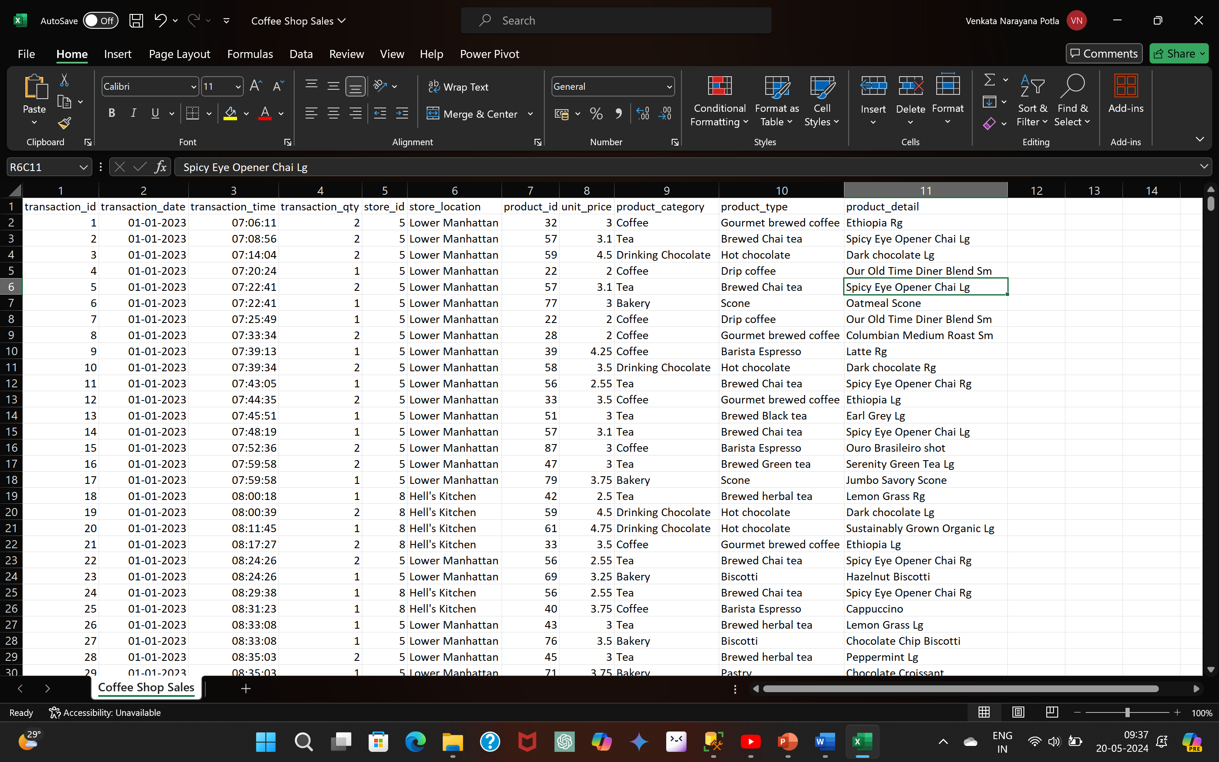

**Raw Data File Preparation**



**Creating Database**

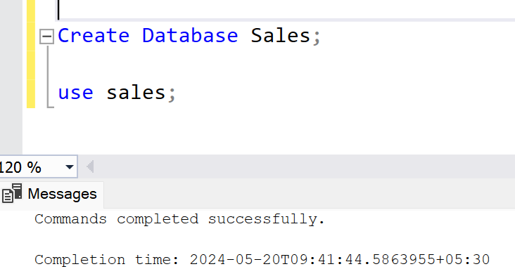

**Importing and Cleaning File**

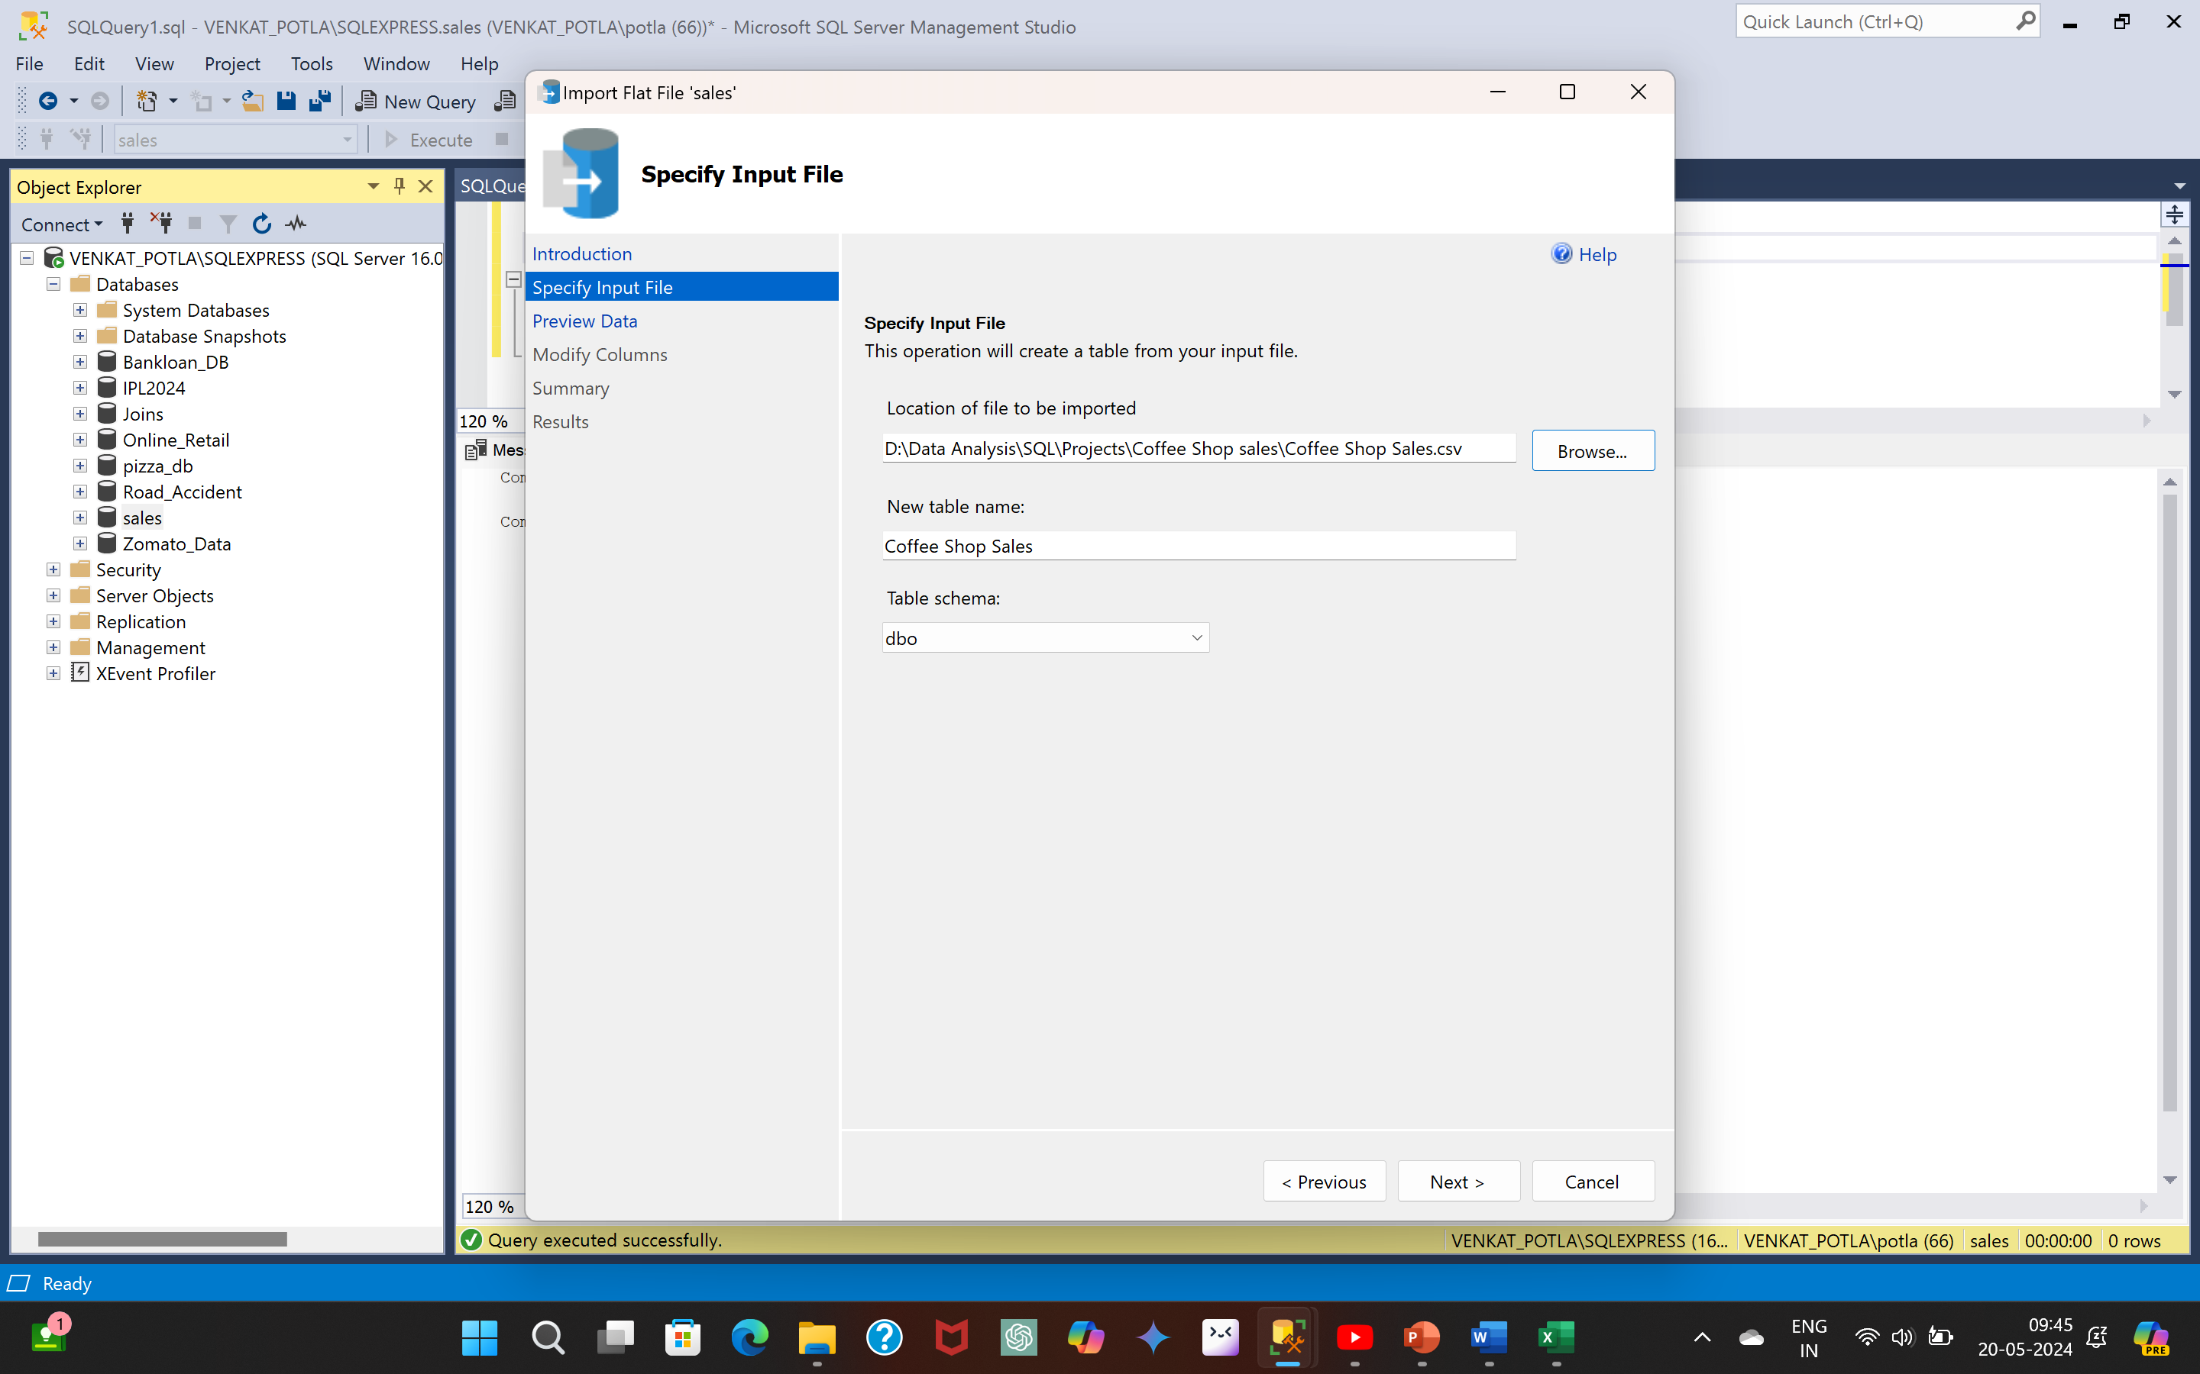 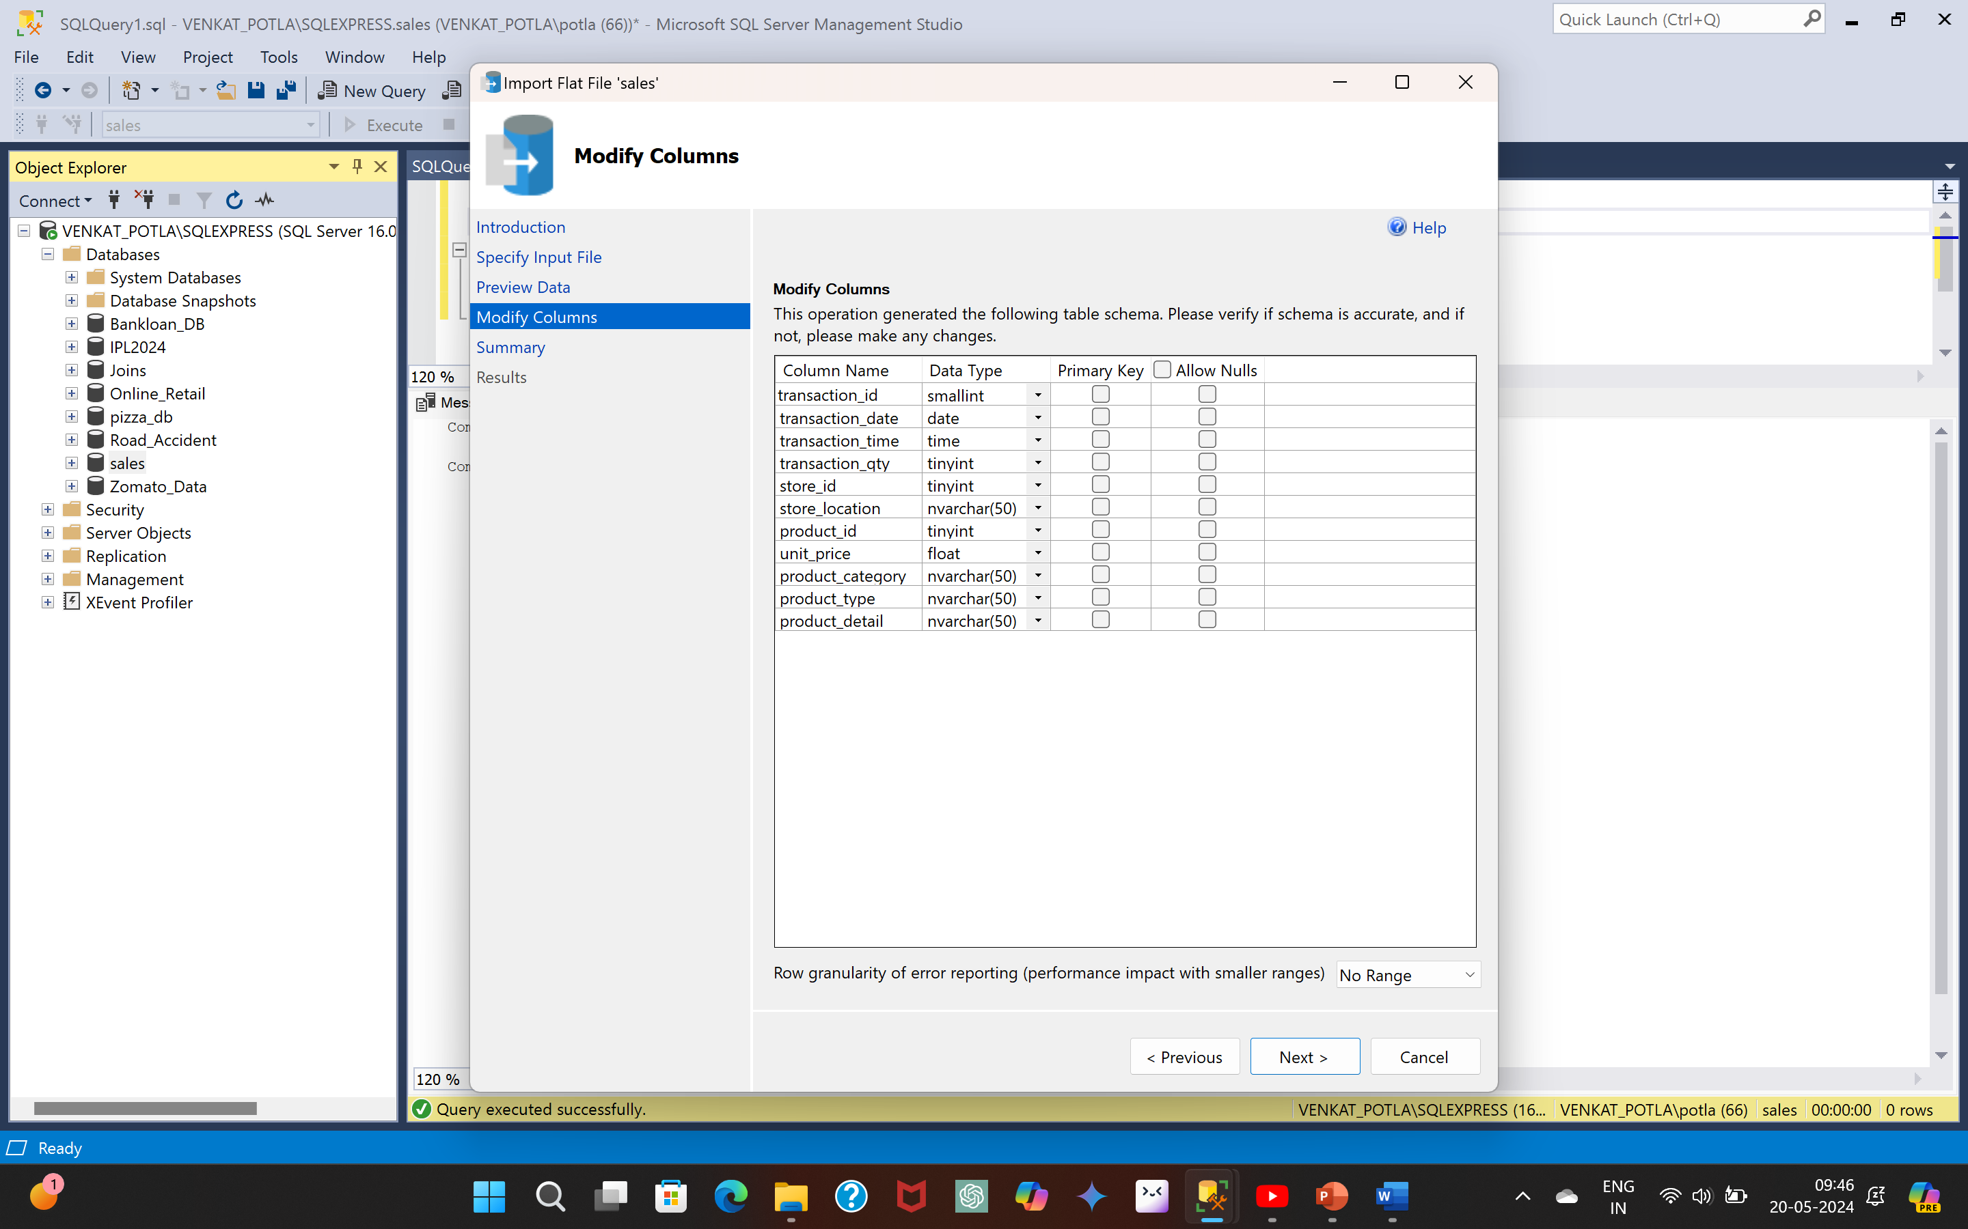

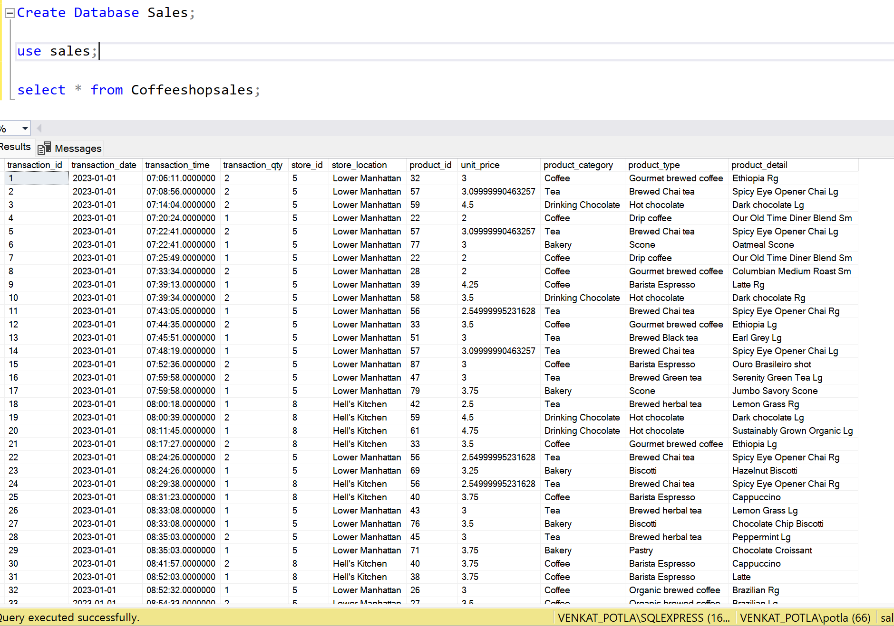

**Firing SQL Queries for Business Requirements**

**1.Total Sales Analysis**

* Calculate Total sales for each respective month